**Day 3:**

Stack : Stack is linear data structure which support the features as First In Last Out (FILO) or Last in First Out (LIFO)

Stack Operation

Push 🡪 to add the data from top to bottom.

Pop🡪 remove the data from top

Peek 🡪 to check top most element present in stack

isEmpty 🡪 verify stack is empty or underflow

size 🡪 to check number of element present in stack.

Queue : Queue is another linear data structure which support the features as First In First Out.

Queue Operation

**Front:** The element to be removed next.

**Rear:** The position where a new element is added.

Enqueue : to add the element from rear

Deque : to remove the elements from front

Peek : to check first element added (ie ready to dequeue)

Size: to check the number of element present in queue

isEmpty: queue is empty or not.

LinkedList : LinkedList is another type of linear data structure which internally use **node** concept to store data.

Node hold the data of any type as well as reference of another node object.

Depending upon type of linked list node can hold value or data of any types as well as one or more than one another node object or reference.

Types of linked list

1. Single linked list
2. Double linked list
3. Circular single linked list
4. Circular double linked list

**Single linked list**

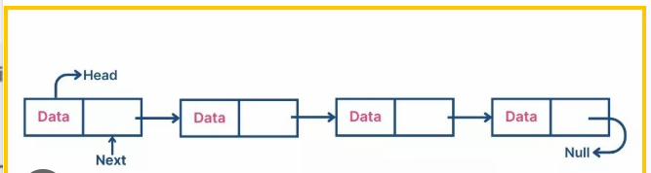

**Double linked list**

